

**Nº4 July 2025**

**NEWSLETTER**

**ACCESSIBILITY OF FINANCIAL SERVICES FOR PERSONS WITH DISABILITIES**

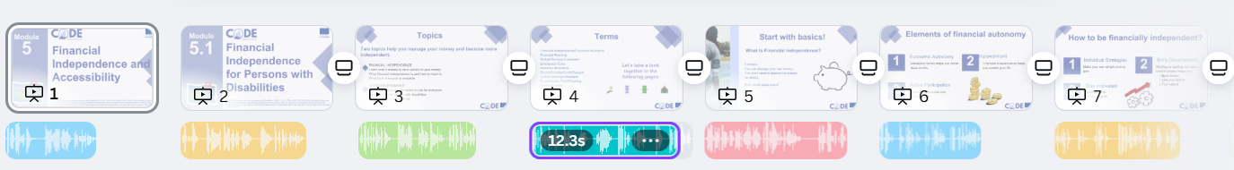

**CODE Training Course**

**We’ve had the pleasure of working closely with a range of professionals: from experts in inclusive finance to accessibility advocates and tech specialists with a focus on artificial intelligence. Together, we’ve looked at every part of the training course – from layout and visuals to audio descriptions and language style – asking ourselves one key question: "Would this be easy to use and understand for someone with a disability?"**

**And we’re not doing this alone. We’ve received valuable input from people with lived experience of disability, whose insights have helped shape the final course in ways we could never have achieved on our own.**

**The result? A training programme that we believe can make a real difference — not only by building knowledge, but by removing barriers that have stood in the way for too long.**

**Very soon, this course will be live and freely accessible to all on our inclusive Moodle-based e-learning platform. Whether you’re a trainer, a learner, a support professional or simply someone curious to learn more, you’ll be able to explore all five modules in your own time and in your own way.**

**Stay with us – the best is yet to come.**

**Dear Partners and Collaborators,**

**Over the past few months, the CODE team has been busy behind the scenes – not only developing high-quality training materials but also making sure they are genuinely accessible to everyone.**

**are fully accessible to everyone.**



**CODE Next Meeting**

**OBJECTIVES:**

**In October 2025, the CODE team will meet in Barcelona to review the pilot results, share feedback, and plan the final steps before the course goes live. It will be a key moment to reflect, adjust, and move forward together.**

**A Big Step Forward: The European Accessibility Act Comes into Force**

**From 28 June 2025, something important will happen across the EU: a long-awaited piece of legislation will come into full effect — the European Accessibility Act (EAA).**

**This new EU law, officially known as Directive (EU) 2019/882, sets out accessibility requirements for a wide range of products and services, including ATMs, online banking, and mobile applications.**

**But what does this mean in practice?**

**It means that banks across Europe will need to make their ATMs more user-friendly for people with disabilities. No more unreadable screens, confusing menus or buttons too small to find or press. Instead, we’ll see:**

* **Clearer visual layouts with larger text and strong contrast**
* **Audio instructions available via headphones**
* **Simple, logical menu navigation**
* **Tactile keypads and embossed controls**

**And here’s the good news: everyone will benefit. These improvements aren’t just for people with disabilities – they’ll make everyday banking easier for older adults, people with temporary impairments, and anyone who has ever struggled with unclear interfaces.**

**For us in the CODE project, this legislation is a game-changer. It aligns perfectly with our mission to make the financial system more inclusive and accessible.**

This project has been funded with the support of the European Commission. This publication reflects the views only of the author and the Commission cannot be held responsible for any use which may be made of the information contained therein.

Project Number 2023-1-FR01-KA220-VET-000162105



**FOLLOW US!**

**Code Project**

**Code Project**